THE UNIVERSITY OF MANCHESTER

Structure-Performance Relationships in Complex System Developments: The Case of Infrastructure Projects in Developing Economies

Nuno Gil*

Working Paper

18 June, 2016

*The University of Manchester,
nuno.gil@mbs.ac.uk

Copyright ©2016, Nuno Gil
Working papers are in draft form. This working paper is distributed for purposes of comment and discussion only.

Structure-Performance Relationships in Complex System Developments: The case of Infrastructure Projects in Developing Economies

ABSTRACT
This study aims to further our understanding of the relationship between structure and performance in developments of complex socio-technical systems in contexts of weak institutions and scarce resources. We ground our research in a sample of capital-intensive infrastructure projects set up to address pressing needs in developing economies. Our analysis reveals two distinct approaches to problem-solving. One involves slow acquisition of multiple critical resources from independent organizational actors during the planning stage (horizontal cooperation) before selecting the suppliers for implementation after an open tender (vertical cooperation). The other approach involves an extreme overlap between planning and implementation enabled by rushing buyer-supplier agreements at closed doors. We find that open horizontal cooperation relies on a sequential process to attenuate uncertainty over implementation, but leads to development timescales wholly inadequate to the problem urgency. In turn, the overreliance of opaque vertical cooperation on improvisation, problem-solving ingenuity and flexibility to overcome ensuing bottlenecks also fails to speed up the development life-cycle. We discuss the implications to literature and policy of this choice between alternatives none of which is unarguably superior.

Introduction
Extant research on the relationship between structure and performance in project-based organisations formed to develop complex socio-technical systems has been mainly informed by phenomena in advanced economies (Hughes 1987, Morris 1994, Miller et al. 1995, Hobday 1998, 2000, Davies and Brady 2000, Flyvbjerg et al. 2003, Gil 2007). As such, this literature presupposes a context of established regulations, laws, and institutions to enforce a public-private divide. It also assumes reasonable availability of management and technical skills and critical resources to achieve the system-level goal. Here, we aim to extend this literature by using the environment of developing economies as a context for the research.
In a western context, a major challenge when planning a new, complex socio-technical system is to acquire critical resources such as finance, regulatory consent, political support, and knowledge of needs-in-use. The resources exist in the environment, but they are directly controlled by multiple legally independent and heterogeneous actors all of which have a stake on the outcome—the so-called ‘project stakeholders’ (Cleland 1986, Morris 1994, Hobday 1998, 2000, Miller and Lessard 2001, Pitsis et al. 2003). These stakeholders will claim rights to directly influence the strategic design choices, this is, the choices that will define the development process and the system. Conflicting goals and shared decision-making power between the promoter and other resource-rich actors lead to horizontal cooperation problems intrinsic to pluralistic arenas (Jarzabkowski and Fenton 2006, Denis et al. 2001,11, Gil and Tether 2011). Resolving horizontal cooperation requires a search for mutually consensual plans through negotiation and deliberative processes, and social norms of cooperation such as compromise and reciprocation. Once consensus emerges, the promoter of a complex socio-technical system can use prices and contracts to align interests with the suppliers which will implement the plans (vertical cooperation). The collective search for consensus invariably leads to slippages in the performance targets over the development life-cycle.
Developing economies create a much messier context for developing new complex socio-technical systems— it is ‘development on the knife-edge’ (Levy 2014). These societies are in transition from traditional lifestyles towards a modern lifestyle which began in the Industrial Revolution (Rostow 1962). In these settings, inter-elite contestation for power and resources is strong; the normative separation between the public and the private is weak; and the use of corruption and force to appropriate private property of others is not uncommon (Wade 2007; Levy 2011). There is also abundance of informal economic activity either to seek rents by breaking the law or circumvent ambiguity in formal rules (Uzo and Mair 2014). Furthermore, a narrow tax base, poor tax morality, and high collection costs starve the public sector of funds. Developing economies thus suffer from multiple “lacks”—in capital, skills, and basic infrastructure networks (Hirschman 1967 p.131); they also lack institutions for supporting markets, mediating conflicts, and enforcing the law—what Khanna and Palepu (2010) call ‘institutional voids’. And yet, once funds are acquired to finance a new capital-intensive development, institutional voids give the promoter of a new scheme sufficient leeway to rush planning tasks and start implementation in order to attempt to achieve the end-goal faster.
The choice between overlapping or not planning and implementation tasks to accelerate development processes is a question germane to management studies. Brooks’ (1975) study on software development was among the first to claim that complex system developments structured as a linear sequence of phases with limited overlap (the ‘waterfall’ model) are slow and ineffective. Subsequent studies on product development performance concluded that overlapping development steps and involving suppliers early on speeds up development whilst gaining flexibility to cope with evolving needs (Clark and Fuijimoto 1991, Iansiti 1995). Alternatively, the time to market products that are outmoded quickly can be reduced by employing an experiential approach which relies on improvisation, design iterations, real-time experience, and flexibility (Eisenhardt and Tabrizi 1995). Both adaptive processes assume that up and downstream design choices are ‘loosely coupled’ (Thomke 1997). Hence the benefits of compressing development outweigh the costs of adapting upstream choices to downstream choices that fall outside the solution space foreseen at the onset of development.
The debate on the value of overlapping planning and implementation has extended to capital-intensive developments of complex systems; here, the overlapped approach has three aims: i) compress the development life-cycle; ii) postpone commitments on downstream design choices until uncertainties in technology and user needs are resolved; and iii) leave more time for collective searches of mutually consensual design solutions without outrightly compromising ambitious deadlines (Pitsis et al. 2003, Gil and Tether 2011). In one-off capital-intensive developments with integral design structures, however, the costs of adapting the upstream design choices to unforeseen downstream choices can be very high (Gil 2007). Hence projects literature that emphasizes efficiency advocates sequential state-gate processes (Cleland and King 1968, Morris 1994). The planning literature too favours a sequential approach to create more accountability for the initial pledges (Flyvbjerg et al. 2003).
Extraordinarily, this unresolved theoretical debate mirrors two distinct approaches to structure capital-intensive developments in developing economies. Development agencies such as the World Bank and Japan International Cooperation Agency (JICA) rule out extreme planning-implementation overlaps. In contrast China state-owned organizations are amenable to experimental approaches. This makes developing economies a suitable setting to help us move the debate forward. To probe deeper into this research question we built a sample of six projects to develop transport infrastructure to meet pressing local needs. The sample varies in two dimensions. First it includes cases where the funders released finance for implementation only after planning was substantially resolved and cases where the two stages overlapped extensively. And second we varied the context surrounding the project. Specifically we studied projects in India, a ‘competitive rule-of-law state’ where political and economic rules have become impersonal although some institutions remain weak; projects in Uganda, a ‘dominant discretionary state’ where political leadership has consolidated its grip on power but most institutions remain weak and the public-private divide is still blurred; and Nigeria, a country in a development trajectory between the aforementioned two countries (Levy 2014).
Our inductive research produces three main contributions. First, we reveal that pluralism is central to understand the performance of capital-intensive developments of complex systems in developing economies, even in contexts where it is arguable if a democratic bargain is on offer. We trace pluralism to two factors: i) the sharing of decision-making power over strategic design choices between the promoters and the funders; and ii) legal frameworks protecting property rights. Second, we show that the propensity for slippages in performance targets (scope, cost, schedule) that is endemic to projects unfolding under pluralism is exacerbated in an economic developing setting. We trace this finding to the lack of umpiring structures to settle disputes (apart from inefficient court systems) and the scarcity of slack resources such as budget contingencies and time buffers to reconcile incompatible goals.
And third, we illuminate the trade-offs intrinsic to the choice to overlap or not planning and implementation. We find that extreme overlaps are attractive for the pledge of quick developments. Under pluralism, this approach relies on opaque vertical cooperation to enable suppliers to have a head start on implementation. However, it carries a high risk of development derailing if improvisation, ingenuity, and flexibility fail to resolve the problems of horizontal cooperation that ensue later on. In contrast, a sequential approach relies on substantive investment upfront in horizontal cooperation to acquire critical resources before striking buyer-supplier deals after open tendering. This approach attenuates overruns in implementation, but pledges timescales that fail to respond to the urgency of the problems.
We organize the remaining of this paper as follows. First, we review our understanding of the structure-performance relationship in capital-intensive complex systems projects. We then introduce our research method and database. In the analysis we reveal how, under pluralism, major slippages in performance targets occur whether planning and implementation overlap or not, but happen at different development stages: in planning when the buyer-supplier agreements are transparent or in implementation when these agreements are opaque. In the discussion, we leverage these insights to advance our understanding of the structure-performance relationship in capital-intensive developments. We conclude with a discussion of implications to practice and policy of this lack of a clearly superior alternative.

Background: The Planning-Implementation Overlap in Complex Systems
The development of complex systems that are made up of many interacting components can be conceptualised as a process of resolving multiple bottlenecks, this is resolving “parts of the system that have no—or very poor—alternatives at the present time” (Baldwin 2015). The system’s bottlenecks fall in two categories. Resolving socio-economic bottlenecks requires a combination of agreements over organizational boundaries and property rights. Resolving technical bottlenecks requires engineering technological solutions for defined problems. The bottlenecks are intertwined. The self-interest of autonomous actors can stymie problem-solving but a socio-economic bottleneck can be removed if a technical solution is found that bridges differing interests. Likewise changes in financial arrangements or regulation can enable technological solutions that otherwise would be unviable. Resolving a system’s bottlenecks is thus like searching ‘through a maze’ (Simon 1962 p.472).
In capital-intensive developments of one-off complex systems, resolving some of the system’s bottlenecks involves a search for mutually consensual solutions (Jessop 1997, Hobday 1998, Gil and Tether 2011). In these settings, multiple actors directly control different resources that are critical to forge ahead. For example, in large infrastructure developments, control of finance, land, knowledge of needs-in-use, and regulatory power is distributed respectively across funders, landowners, operators, and regulators (Lundrigan et al. 2015). Each autonomous actor who individually controls one of these critical resources has a stake in the outcome of the development process. Complicating matters some of these resources cannot be acquired through transactions in that they do not lend themselves to be defined, counted, and paid for (Baldwin 2008). And yet, in exchange for committing to contribute individually-owned resources to the enterprise, each actor will claim rights to directly influence one-off strategic design choices—a process that Miller and Lessard (2001) call ‘project shaping’. This sharing of decision-making power between autonomous, self-interested actors with differing ideologies, beliefs, and know-hows creates a pluralistic arena.
Pluralism makes system developments hard to decompose into ‘isolable subsystems’ or individually-owned ‘modules’ and agreed-upon interface rules (Alexander 1964, Simon 1962, Baldwin and Clark 2000). Rather, under pluralism, many one-off strategic choices are political and require a lot of interaction between development participants. This makes mutual-gains bargaining, interests-based negotiation, and cooperation critical mechanisms to build consensus on the system-level goal and how to achieve it (Denis et al. 2001, 11). Once consensus is built, market forces can be used to select the suppliers and contracts used to simulate a bureaucracy and encourage vertical cooperation (Sinchcombe and Heimer 1985).
The ambiguity in value creation that is endemic to developments of long-lived systems amplifies difficulties in building consensus amongst independent resource-rich actors. Whenever multiple claimants to single strategic choices adopt different temporal frames of reference, it becomes much harder to reconcile their individual preferences (Gil and Tether 2011, Ostrom et al. 1994). Complicating matters, ambiguous developments of one-off complex systems are not amenable settings to develop a robust social contract, a mechanism which by definition requires clarity in goals and mutual credibility (Gibbons and Henderson 2012). Under pluralism, the risk is thus high that indecision escalates and controversies drag unresolved for a long time (Denis et al. 2011). Furthermore, disputes over the evidence that each party produces to back up her claims can lead to a risk of inaction and reversal of choices previously agreed upon—what Langley (2005) calls ‘paralysis by analysis.’
This risk of impasse makes it tempting to overlap planning and implementation to pre-empt the reversal of strategic design choices. Once implementation starts, the costs of reversing upstream decisions escalate which makes it harder for resource-rich actors to defect and withdraw their commitments without losing face. Overlapping planning and implementation can also be attractive to create an option to achieve the end goal faster (Gil and Tether 2011). Furthermore, rushing planning to start implementation work leverages what Hirscham (1967) calls the ‘hidden hand principle’—this is the idea that inadequate planning and utopian visions enable people to misjudge the nature of the tasks and underestimate the real costs. This is helpful to offset people’s tendency to underestimate the problem-solving power of creativity, ingenuity, and flexibility; as Hirscham (1967 p.28) puts it, “the hiding hand is essentially a way of inducing action through error”.
However, a decision to progress a capital-intensive development into implementation when interdependent strategic choices and system’s bottlenecks are unresolved creates high uncertainty in the requirements. This uncertainty can stimulate the development of dormant problem-solving capabilities, strengths, and skills. But it also increases the risk of high adaptation costs if the system is hard to decompose, and impairs the production of reliable cost and/or schedule forecasts (Morris 1994). High uncertainty in requirements also makes planning tasks more vulnerable to optimism bias from the promoter, and to deliberate misrepresentation of the socio-economic value of the enterprise (Flyvjberg et al. 2003).
Given these downside risks, the choice to overlap planning and implementation tasks in capital-intensive developments of one-off complex systems is regulated in western contexts especially in publicly-financed schemes. In the UK, for example, any major public infrastructure project can only start after the land is acquired and a planning application approved. Regulation is enforced by a system of ‘referees’ or ‘umpires’ (e.g., courts, public inquiries, Parliamentary committees) which are empowered to settle disputes. Capital-intensive private industries enjoy more flexibility to overlap planning and implementation tasks insofar they stay within legal rules and regulatory frameworks. For example, extreme planning-implementation overlaps are the norm in the development of semiconductor fabrication facilities. For chipmakers, the potential benefit of reaching the market first with a new commercial product way outweighs any adaptation costs stemming from the concurrent development of new chips and the factories where the chips will be made (Gil et al. 2006).
In developing economies, the overlap between planning and implementation in capital-intensive developments such as infrastructure projects is much less regulated (Brautigam 2011, Levy 2014, Hirchman 1967). Hence, once the financial bottleneck is resolved, a choice ensues on whether to overlap or not planning and implementation given it urges to solve the problem. We turn now to discuss how we set up to explore alternative ways to structure the development process by looking to urgent infrastructure projects in developing economies.

Research Design, Sample, and Methods
Our research is inductive and follows a multiple case study research method (Eisenhardt 1989, Yin 1984). Multiple case studies are a suitable approach to yield conceptual insights over under explored phenomena because they enable to incorporate contextual and temporal dimensions in the analysis (Eisenhardt and Graebner 2007). Our cases consist of capital-intensive development projects to produce basic transport infrastructure necessary to meet an urgent local need. Following recommendations for theory building through inductive studies, we built a diversified sample (Siggelkow 2007). Specifically, our sample varies in two dimensions. First, we varied the source of finance. This was important so as to include cases of extreme planning-implementation overlap (enabled by a constellation of Chinese actors) and cases with a sequential approach to development (enabled by the World Bank or JICA).
And second, we varied the context. New infrastructure projects involve vast sums of money which makes them vulnerable to illegal activity, and the more so the more fragile the institutional environment is. Embezzlement of funds, corruption, and fraud could thus explain slippages in performance targets. To control for this, we included projects in Uganda, a dominant state (so-called “big-man rules”) where disparity between the power of the rulers and opponents is large and the public-private divide is weak; India, a “rule-by-law” state where politics is way more competitive and impersonal even if other aspects of democratic sustainability are yet to be achieved; and Nigeria, a country in between the two ends of the spectrum (Levy 2014). (In the 2014 Transparency International corruption perception index for 175 countries, India ranks 85, Nigeria 136, and Uganda 142). Table 1 summarises for each case the system-level goal, the urgency of the local problem, the organizational structure of the project promoter, and the data sources.
Cases | Western Freight Corridor (India) | Eastern Freight Corridor (India) | Blue and Red Metro Lines (Lagos-Nigeria) | Bus Rapid Transit corridor (Lagos-Nigeria) | Kampala-Entebbe Expressway (Uganda) | Kampala Road Modernization  (Uganda)
System-level goal | Develop a 1504km dedicated freight railway between Delhi/Dadri and Mumbai | Develop a 1,856km dedicated freight railway line between Dankuni and Ludhiana (near Kolkata) | Develop a 27.5km urban railway line (‘blue line’) and a 30km line in Lagos, Nigeria’s capital (‘red line’) | Develop a 175km-long network of ten segregated road corridors for public buses | Develop a 37km highway between Kampala (capital) and the main international airport (Entebbe) | Develop the 1,200 km road network of Kampala, Uganda’s capital
Problem urgency | High  Extra capacity to transport goods essential to diversify India’s economy away from agriculture into manufacturing | High  Extra capacity to transport coal and produces essential to attenuate India’s energy and food problems | High  6-hrs average commute; >300,000 estimated daily ridership (weekday) | High  6-hrs average commute; public transport less than 2% of 20 million/daytrips; | High  2-3 hours to do 37km due to traffic jams and poor road condition; 30min journey once expressway opens | High  Over 90% of urban roads unpaved; lack of traffic lights, sidewalks; chronic traffic congestion
Promoter organizational structure | 4-party coalition  India government, DFCCIL; Indian Railways; JICA (*) | 4-party coalition:  India government; DFCCIL; Indian railways; World Bank (*) | 3-party coalition:  Lagos government; Lamata; CCECC (#) | 4-party coalition:  Lagos government; Lamata; World Bank; French Agency | 4-party coalition:  Uganda government; UNRA; China Eximbank; CCCC (§) | 3-party coalition:  Uganda and Kampala governments; World Bank
No. interviews | 21 (15 overlap w/ Eastern DFC) | 19 (15 overlap w/ Western DFC) | 18 (15 overlap w/ BRT case) | 19 (15 overlap w/ railway case) | 24 | 20
No. and description of the organizational actors interviewed | #9  DFCCIL (Indian Railways’ agent), Indian Railways, central government, JICA, consultants (#3), public agencies (#2) | #8  DFCCIL (Indian Railways’ agent), Indian Railways, central government, consultants (#3), World Bank; public agency | #9  Lagos government, Lamata, CCECC, consultants (#4), Nigeria Railways, World Bank | #7  Lagos government, Lamata, bus operator, Ekobank, World Bank, consultants (#2) | #12  government ministries (#3); UNRA, Road fund agency, CCCC, World Bank, consultants(#3); development agencies(#2) | #8  government ministries (#2); KCCA; World Bank; consultant; development agencies (#2); road fund
Archival data  No. of documents by category (press articles excluded) | #83 (51 shared with Eastern corridor)  7 presentations;  11 external communication;  65 technical & financial reports | #82 (51 shared with Western corridor)  4 presentations  12 external communication  66 technical & financial reports | # 17 (5 shared with BRT case)  6 presentations  9 technical & financial reports  2 external communication reports | #44 (5 shared w/ railway case)  7 presentations  32 technical & financial reports  5 external communication reports | #23  1 presentation  6 technical & financial reports  16 external communication reports | #40  1 presentation  8 external communications  31 technical & financial reports
(*)JICA- Japan International Cooperation Agency; DFCCIL-Dedicated Freight Corridor Corporation of India Ltd.
(#)CCECC-China Civil Engineering Construction Corporation; Lamata –Lagos Metropolitan Area Transport Authority; (§)CCCC -China Communication Construction Company; UNRA- Uganda National Roads Authority

Data Collection
Data collection started in 2013 and lasted 2 years as part of an independent research to advance our understanding of projects to develop complex socio-technical systems using developing economies as a context. We adopted two approaches to gain access to data. In the case of India, we cold called the chief executive of the public agency formed to develop a new railway system—the Dedicated Freight Corridor Corporation of India Ltd (DFCCIL)—who gave us access to the research site. In the other cases, we collaborated with civil servants who were on study leave in our university. Hence one graduate student-cum-civil servant helped us to gain access to the top management team of LAMATA, the public agency set up to modernize the transport infrastructure of Lagos, Nigeria’s capital; and another graduate student-cum-civil servant helped us to gain access to the top management teams of UNRA, the public agency leading the development of the Kampala-Entebbe Expressway in Uganda, and of Kampala Capital City Authority, the local government of Kampala, Uganda’s capital.
In all cases, we then adopted a snowball approach (Biernacki and Waldorf 1981) to access other organizational actors directly involved in the infrastructure projects including funders, consultants, contractors, public agencies, and government departments. Through one to two week visits to each site, we conducted 91 formal interviews up to 2-hours long; we tape recorded all interviews. We conducted follow-up interviews by phone and e-mail to probe deeper into particular issues, double check a verbal account, and bridge gaps in our database. We were not asked to sign non-disclosure agreements but were explicitly asked not to use particular quotes. To gather extra data and allow for member checks (Lincoln and Guba 1985) we shared factual and chronological accounts with the respondents. In the Uganda and Nigeria cases, we also produced detailed hand-recorded verbatim notes of the informal chats which we entertained during three-hour long visits to the construction sites.
To improve data accuracy and the robustness of the insights (Jick 1979) we triangulated the verbal accounts against archival data (Miles and Huberman 1994). The public agencies promoting the developments shared with us technical and financial reports, power point presentations, and articles published in governmental publications. We complemented this information with a wealth of information found on-line. First, the projects funded by the World Bank and JICA are well documented online. Key documents supplied by the funders include detailed technical reports assessing the scheme’s viability and progress reports. There is limited information publicly available on schemes financed by the Chinese actors. But all the developments were closely monitored by the local presses (in English) particularly in terms of announcements of performance targets, achievement of milestones, and land disputes. To encounter relevant articles, we googled the names of the top management staff and elected politicians who were directly involved in the new infrastructure developments.

Methods
Following recommendations for inductive reasoning (Langley 1999, Ketokivi and Mantere 2010) we started the analysis by producing detailed chronological and factual accounts for each case to guard against account bias (Miles and Huberman 1994). We then analysed the data using coding and tabular displays (Strauss and Corbin 1990). In addition, we developed stylized maps of the development life-cycles. In each map, summarised in Figures 1-3, we captured the evolution of the developments along three dimensions: strategic design choices, project organizational structure, and performance targets (cost, schedule, scope). As we iterated between reviewing data, constructing the development life-cycle maps, and theory building, an argument emerged suggesting two distinct approaches to achieve the system-level goal. These approaches vary in the extent planning and implementation tasks overlap and in the transparency over the supplier-buyer agreements. We continued to iterate between data analysis and conceptual development until we reached theoretical saturation. We turn now to present the analysis and then to discuss the contributions to literature and policy.

Analysis
We organize the analysis by discussing first the root causes of pluralism in our sample of new infrastructure development projects in developing economies. With pluralism as a backdrop, we then analyse the structure-performance relationships. We trace evolution in performance to evolution in the project organizational structure and differing structures of the development processes. The development life-cycle maps for the six cases represented in Figures 1-3 and the excerpts of data in Tables 2-3 illustrate the analysis that follows.

The emergence of pluralism in a developing economy
A pluralistic structure boils down to power sharing across multiple independent actors with conflicting goals. The heterogeneity of belief-systems, knowledge bases, and ideologies across actors pre-empts efforts to set up a meritocracy-based authority (Denis et al. 2001, 11). Hence under pluralism many strategic choices involve negotiation and bargaining that leverage cost-benefit data produced by the technocratic teams of the disputants.
Across our sample we regularly observed the emergence of pluralism at the onset of the development processes. Table 2 summarises the evidence. We traced pluralism to two main factors. First is the interdependency between the promoter and the funders. This occurs because governments in developing economies are cash-strapped and struggle to borrow money at reasonable economic rates; private actors also shy away of capital-intensive investments wary of what might happen once the project is completed and the bargaining power shifts to government (Vernon 1977). It is within the remit of development agencies to finance capital-intensive infrastructure. But agencies are not altruistic and are accountable to many principals for capital spending. Hence they want to directly influence strategic choices.
Table 2 – Summary of Evidence on the Emergence of Pluralistic Development Contexts
Case | Sharing of Power | Financing Mechanism (*) | Illustrative quotes of the pluralistic environment surrounding the new infrastructure development projects
Western corridor (India) | JICA; DFCCIL (Indian Railways’ agent) landowners, public agencies, state/federal governments | Japanese STEP loan (6.4billion ~75% initial cost forecast)  +  Gov’t India | The JICA requirement that asks the lead partners to be Japanese is a major concern. We [DFCCIL] don’t have enough bidders. We’re working on trying to relax that policy  The Indian side was very clear they wanted diesel. JICA insisted upon electrification….It was JICA who basically negotiated with the Gov’t India the resettlement and rehabilitation policies
Eastern corridor (India) | World Bank ; DFCCIL; andowners, public agencies, state/federal governments | World Bank loan ($2.725bn ~51% initial cost forecast)  +  Gov’t India | Lump sum, design-build contracts was an innovation suggested by the World Bank. Indian Railways has never done things that way  We (DFCCIL) can act as the land acquisition officer. But we’ve appointed people from the state governments to act on our behalf. We’ve also compromised our alignments to acquire a lot of the land
Lagos metro blue and red lines  (Nigeria) | CCECC (Chinese contractor); LAMATA (local government’s agent) landowners; public agencies; local/ federal governments | Gov’t Lagos, $350m World Bank loan, CCECC suppliers’ credit | We needed to avoid that land because to get them [military] to move out was going to be difficult. So we moved our alignment. ..If you go to court to try prove your rights you won’t achieve much. Definitely in Nigeria you won’t. If you negotiate, you achieve more.  The numbers for the red line are mindboggling, but the challenge has been how to use the land of the federal railway corridor That’s what stalled the project. Just politics, all about who takes the glory for this job
Lagos Bus Rapid Transit corridors (Nigeria) | World Bank, French agency; LAMATA (local government’s agent) public agencies, landowners; governments | Pilot BRT: WB loan (~$11m ~20% of total cost) + Gov’t Lagos  BRT Extension: $150m WB loan + $100m French Development loan | The state government and Lamata needed authorization from the federal government who controlled the road… cooperation was difficult because the two governments were run by different political parties  The World Bank did the pilot concept study, but did not finance construction...the only way we [Lamata] could get the project going was if the state governor believed he could create political mileage out of it, so we said we could do it in about 2 or 3 months’ time
Kampala-Entebbe airport expressway (Uganda) | China Eximbank; CCCC (Chinese contractor), landowners; Uganda National Roads Authority (Uganda) | China Eximbank loan ($350m ~74% initial cost forecast) + Gov’t Uganda | Land belongs to the people...if you require land you must acquire it through legal procedures ….if landowner puts a court injunction, you can’t access the land  The idea came after the governments of Uganda and China interfaced …the conditions that the supervisor and the main contractor will be Chinese were part of the China Eximbank loan
Kampala roads modernization program (Uganda) | World Bank ; elected leaders; landowners; local/federal governments | $33.6 million  WB loan (1st phase) + $3.5m Gov’t Uganda  $175m WB loan (2nd phase) + $9 million Gov’ Uganda | Our land reserves have been encroached by illegal developments. But the World Bank has the policy which requires you to first compensate anyone who you have to remove ... if it was just us [Kampala local government], we would remove them without compensation.  People think that if land belongs to government it belongs to them ….When we move in to evict, politicians say, ‘no, don’t disturb them’
(*) JICA Special Terms for Economic Partnership (STEP) loans promote development assistance with a distinct Japanese profile through technology transfer utilizing advanced Japanese technology and know-how to a development country.
International Bank for Reconstruction and Development (IBRD) loans include finance at market rates, knowledge transfer, and technical assistance
The cases of the two India’s dedicated freight corridors illustrated in Figures 1a,b and Table 3 are telling. The development of 6 railway lines (‘golden quadrilateral’) dedicated to freight was idealised around 2005 between the government of India and Indian Railways, the public agency in charge of the railways. The idea was spurred by a sense of a deep crisis. By then the country’s Victorian railways operated way above design capacity and had lost fifty percent of the lucrative freight transport to the roads. This shift had left the main roads chronically congested; it was also undermining the viability of Indian Railways, which relied on freight tariffs to cross subsidize some of the lowest tariffs worldwide for passengers:
Railways are India’s lifeline…Everybody looks at this [dedicated freight corridors] as a national thing. People will be questioning if the project is slow or why it cannot be done faster. But there are no opponents…the project is needs based.
Resolution for the financial bottleneck emerged in 2007 when the government of Japan agreed to finance three quarters of the forecast cost of the Western corridor. But it would be a tied loan under the Special Terms for Economic Partnership, and thus with strings attached. And indeed JICA suggested multiple changes to strategic design choices made by Indian Railways including: i) moving from diesel to electric traction; ii) increasing the capacity of the train cars; and iii) adopting a minimum of thirty percent of Japanese technologies. When the World Bank warmed up to the idea of financing two thirds of the initial forecast cost for the Eastern corridor, more changes ensued as DFCCIL (the semi-autonomous agency set up by Indian Railways to develop the scheme) had to adopt the bank’s policies on environment, procurement, and land acquisition. During the many years it took to negotiate both loans during planning, the performance targets evolved as summarised in Figures 1a,b and Table 3.
<Insert Figures 1a,b and Table 3 about here>
The second major source of pluralism was the local politics around land acquisition. Across our sample it fell on governments to directly finance the costs of land acquisition. Local laws empowered the governments and their agents to compulsory buy land, but land take was a sensitive issue as many landowners either did not want to move out, or demanded more compensation than what was on offer. Land disputes were quick to make headlines in the local presses and to become political footballs. To avoid disputes from dragging unresolved for years in the court system, the promoters sought major detours to the routes. If detours were not an option, the promoters faced lengthy negotiations to acquire the land.
One good example is the case of the 37km expressway linking Kampala, Uganda’s capital to the main international airport in Entebbe illustrated in Figure 2a and Table 3. The project was urgent for the socio-economic development of Kampala, a city with around 1.8 million people (half of the country’s urban population) and responsible for half of Uganda’s GDP. The 37km car journey between Kampala and the airport could easily take 3 hours during the day. And yet, the scheme suffered many setbacks as disputes with powerful land owners emerged throughout implementation. In some cases the cash-strapped promoter moved the route to avoid paying exorbitant compensations (in its view). In other cases, the promoter pragmatically started to implement the sections of the highway to the right and to the left of the land yet to be acquired as it waited to resolve the bottleneck.
<insert Figures 2a,b around here>
Systematically, our findings suggest that the escalation in performance targets due to difficulties in resolving land disputes was exacerbated by the lack of slack resources and ineffective umpiring structures. Slack resources such as budget contingencies enable to reconcile incompatible goals without resolving conflict (Cyert and March 1963). In the UK, for example, the budgets for complex developments have contingencies built in of up to 40% of the cost forecast at the onset of planning. These contingencies create a buffer to finance concessions to disputants whilst keeping the budget stable. But in our cases, the funders ruled out any idea of financial slack. Complicating matters, we did not encounter any umpiring structure to help resolve conflicts apart from the ineffective court system. Hence dispute resolution could take years, creating a dilemma as to overlap or not planning and implementation tasks. We turn now to analyse two approaches to address this dilemma.

Improvisation under Extreme Planning-Implementation Overlap
Overlaps between planning and implementation in capital-intensive developments are not uncommon. The approach recognises the processes necessary to acquire different resources and agreeing strategic choices unfold at different speeds. Overlapping the two stages can thus help to speed up things, although it also increases the risk of rework (Gil and Tether 2011).
In our sample, the two schemes with major involvement of Chinese actors regularly embraced an extreme overlapped approach. In these cases implementation started soon after a buyer-supplier agreement was forged through vertical cooperation at closed doors. To get a head start on implementation, this approach leveraged suppliers’ credit for a grace period and land already under the control of the promoter. It also trusted on the promoter’s capacity to flex and improvise to eliminate any bottlenecks that could emerge later on due to lack of cooperation with other resource-rich actors. Our analysis uncovers a systematic optimism bias in the problem-solving capacity of improvisation, ingenuity, and flexibility—both developments that adopted an extreme overlapped approach derailed after complicated system’s bottlenecks emerged. Another cost of this approach was a lack of transparency around the vertical cooperation process; one Nigerian official explained:
we put the cart before the horse and start building stuff without a translated design from Chinese…the fact they [CCECC] are owned by the China government helps them to be very competitive …they just want to sort out your problems and do the work…they don’t mind ‘getting their hands dirty’ [if you will] as long as the business case works for them
A good example is the Uganda’s Entebbe-Kampala expressway illustrated in Figure 2a and Table 3. Only a constellation of Chinese actors expressed interest in attempting to rapidly resolve this problem. To speed up things, the Uganda government, the national roads authority UNRA, and the China Eximbank agreed a concept design and cost and schedule targets at closed doors. As part of the $350 million loan (two thirds of the initial cost forecast), the contract was awarded to the Chinese firm CCCC with no-bid arrangements. This was a controversial decision since CCCC had been recently blacklisted by the World Bank for corruption and the constitution prescribed competitive bids for major procurement contracts. The deal also relied on a future change in the laws that prohibited toll roads.
Once implementation started, disputes emerged around private land. To speed up construction and bring costs down, for example, CCCC designed the route to go through a stone quarry from which it planned to extract stone. But the plan backfired after the owner rejected the compensation—‘part is greed, part is legal issues. Uganda law doesn’t favour development, but we’ve to work within the law’, said a CCCC manager. With the government cash-strapped and no mechanism to resolve disputes apart the court system, the dispute dragged unresolved. Implementation progressed by improvisation at the expenses of efficiency and effectiveness: detours were made where possible and construction progressed only where land was available. On a positive note, Parliament succeeded to change the law necessary to toll the road, disarming the cynics who argued it would never happen.
The case of the blue metro line in Lagos, illustrated in Figure 3a and Table 3, provides a second example of improvisation under extreme overlap. The scheme was part of a 2018-20 vision for the city developed in 2006 by Lamata, a public agency sponsored by the World Bank and set up to tackle the transport problems of Lagos. The city with almost 20 million people was forecasted to become Africa’s largest city by population in a few years’ time, but still lacked the most basic public transport. People relied on an incipient road network and informal buses (‘danfos’ and ‘molues’) to move around, and 6-hour daily commutes were the norm. The 2018-20 vision included 6 railway lines; for Lamata, it was a priority to first develop two rail lines: the blue line, for which local government controlled some land, and the red line which would run along an existing federal railway corridor. In 2009 Lamata awarded a contract to develop the blue line to CCECC, a Chinese firm, after a tender for which only two firms qualified. CCECC started implementation one year later on suppliers’ credit for a grace period. Getting this line done was critical for Lamata officials:
Nobody thought about rail for Lagos …nobody would say, ‘can we dare to do this?’ … the first time we [LAMATA] told the Lagos State Commissioner that we needed a railway, he laughed and said, “Come back to the earth. You, guys, are in the clouds.”
Implementation of the blue line started concurrently with the processes to acquire land and finance to start paying CCECC once the grace period expired. As implementation progressed, improvisation ruled. First, the route was changed after the military refused to sell some critical land. Then a third of the line was put on hold after the federal government demurred to supply another parcel of critical land. Albeit a struggle to find finance to start paying CCECC, implementation continued to bumble along. In 2015, the promoter secured a loan from the World Bank that has created expectations that a first small section will open by 2017/18. More frustrating for Lamata has been the failure to acquire federal land and finance for the much-needed red line (favoured by the WB) after more than 10 years of talks. In this environment, Lamata officials appreciated the Chinese overlapped approach to development:
Let me give you a good thing about CCECC … they are really ready to deliver and satisfy their clients…When you award them a particular contract it takes less time for them to start construction and mobilization….They won’t say ‘the government isn’t paying, I won’t work’…. I think it’s one of the reasons for the success of the Chinese companies in Africa
We turn now to analyse the sequential approach to capital-intensive developments.

A linear, sequential approach to capital-intensive developments
A linear, sequential approach to capital-intensive developments is an alternative model to structure capital-intensive developments. The advocacy for this model can be traced to social norms rooted in the project management profession which emphasize scope freeze and control systems over flexibility (Lenfle and Loch 2010). From this perspective, projects which miss the initial performance targets ‘fail’ which impairs professional careers. These norms shape action in agencies such as the World Bank and JICA, and these funders do not disburse funds until they are confident that the implementation can unfold as planned.
One good example is the case of the development of rapid bus corridors in Lagos illustrated in Figure 3b and Table 3. When the World Bank sponsored the establishment of Lamata in 2006, the idea to develop 10 segregated busways gained wide support. The plan was to complete the 173 km network by 2020. But first the World Bank insisted in building Western organizational capabilities—‘we felt there was a need to create an agency that was appropriately structured to drive the level of transportation in Lagos’, said one official. Concurrently, the bank agreed to finance the design of a pilot corridor which opened two years later in 2008. But then things slowed down dramatically. It took four years of cooperation to acquire finance and land for implementing a 14 km extension of the first BRT corridor during which the cost forecast duplicated. The implementation stage stayed largely within budget but took three instead of two years. Whilst the World Bank argues LAMATA is a ‘beacon of good public management in a dark place’, it is unclear if and when the whole vision will be achieved—‘one corridor is better than nothing’, said one WB official.
The case of the six dedicated freight corridors in India, illustrated in Figures 1a,b, offers a second example. The initial 2007 plan was to open the first two corridors by 2012. The idea was well received by JICA and World Bank conditional on sequential developments. Both funders ruled out disbursing any funds for implementation before 80% of the land was acquired. The funders also suggested breaking each corridor into multiple smaller sections which could be planned and implemented sequentially. Planning for the first sections of each corridor took between 4 and 6 years. In addition to difficulties in acquiring the necessary land and regulatory consent, the funders introduced rigid policies to procure suppliers that further delayed progress. Delays notwithstanding, a sequential approach has created greater certainty in implementation. The latest forecasts suggest moderate slippages in the cost targets; the two corridors are due to open partially in 2018 but it is unclear when they will be fully completed. As for the other much-needed corridors, they remain a ‘dream’ on paper, one officer said.
The case of the road improvement project in Kampala in Figure 2b provides a last example. The urgency to improve the roads of Kampala was indisputable. In 2007, the population was projected to grow at 4% annually and 1.5 million people entered the city daily. But less than 25% of the roads were paved; and the paved roads had hardly been maintained since the 1940s. To move faster, people relied on informal motorcycle taxis (‘boda-bodas’) that could snake through gridlocked traffic and potholed roads. But ‘boda-bodas’ were dubbed the ‘silent killers’ because of the thousands of accidents and fatalities every year. The road modernization program started in 2007 when the World Bank signed off a $33.6 million loan to support the first phase of a three-phase program to modernize Kampala in 10-years; the approach was sequential as explained by one official:
The project was conceived as the first of a three phase Adaptable Program Loan to provide support for the implementation of Kampala’s long-term development program which would require step-by-step policy reform and institutional development over a sustained period
The first phase encountered multiple setbacks and took 7 years instead of 3 years to deliver. During this period the funder insisted in developing the organizational capacity of the local government. Investments thus went to develop a land use database, reform financial and fiscal services, liberalise service provision, and improve development skills. In that period the WB helped to improve 12km of roads, a far cry from the initial plan to rehabilitate 26km of tarmac roads and 14km of unpaved roads, and a marginal improvement considering the hundreds of kilometres of unpaved roads. Still, by 2014, Kampala was a city ‘on the rise’ in the WB view even if the traffic problems had worsened as the population had grown at 5 percent annually and markets of used cars had flourished. A second 5-year $175m phase was launched by the WB in 2014, allocating 90 percent of the funds to improve the roads and assuming public funds to acquire land. The aim was to upgrade between 100 and 200km of the city roads by 2020. But there was scepticism about the extent this goal could be achieved:
The difficult part is determining the land values [and] whether certain people are eligible or not…everyone, irrespectively of whether they settled in the road reserve or not, wants compensation…for the WB, whoever is being deprived of a livelihood should benefit. Yet government thinks that if you settled in the road reserve you shouldn’t get compensation.
All in all, our analysis suggests two very different approaches to structure capital-intensive developments under conditions of urgency and resource scarcity. One approach allows for an extreme overlap between planning and implementation. This approach is attractive for the pledge to speed up things but carries major costs. First, it lacks transparency over the vertical cooperation behind the buyer-supplier deals; and second, it cannot offer any certainty of meeting the performance pledges if improvisation, ingenuity, and flexibility cannot resolve bottlenecks created by lack of horizontal cooperation among resource-rich actors.
The attractiveness of the linear, sequential approach is more stability in the performance targets during implementation and the safeguards built in against graft. But the time it takes to resolve horizontal cooperation, a prerequisite to start the capital-intensive implementation, is a major disadvantage from the perspective of the local actors. Importantly, a sequential approach attenuates but cannot eliminate slippages in targets during implementation. For example, the lack of enforcement structures, and common knowledge that funds have been committed to acquire land, creates real risks that land acquired in planning is occupied back by squatters or seized illegally or fraudulently by predators. On balance, it seems fair to say that benevolent local actors genuinely eager to solve local problems are between a rock and a hard place. We turn now to discuss how these findings advance our understanding of the structure-performance relationship in capital-intensive developments of complex systems.

DISCUSSION
We return now to the research question central to this study: to overlap or not planning and implementation in capital-intensive developments of complex systems. The overlapped approach is rooted in studies of high-speed environments (Iansiti 1995, Eisenhardt and Tabrizi 1995). In these settings the gains for products that reach the market first outweigh the adaptation costs. Furthermore, ‘nearly decomposable’ design structures dampen the cost of delayed commitments and design iteration (Symon 1962, Baldwin and Clark 2000).
In contrast, there is no consensus over the value of overlapping development steps in capital-intensive projects. These developments produce one-off systems that impact multiple actors with conflicting goals. If non-excludable development participants with rivalrous preferences share decision-making power, design choices become ‘common-pool’ resources (Gil and Baldwin 2013). Under these circumstances, the overlapped approach can lead to high costs to adapt upstream choices to the preferences of the claimants who arrive late to the development process. Hence a research strand that emphasises control systems, efficiency, and reliability argues that the overlapped approach lead to rework, delays, and a deficit in accountability (Morris 1994, Flyvbjerg et al. 2003, Cleland and King 1968, Merrow et al. 1988). In contrast, research that emphasizes effectiveness argues this approach permits to speed up development without forcing premature commitments (Pitsis et al. 2003, Miller and Lessard 2001). For example, a ‘Last Responsible Moment’ policy enabled to start building Terminal 5 at Heathrow airport whilst continuing to adapt the design to evolving needs (Gil and Tether 2011). The lack of comparative studies has made it hard to further this debate.
Here, we attempt to move the debate forward by, first, factoring in the evolution of the project organization structure into a comparative analysis of alternative process structures; and second, by casting a wider net over the development life-cycle. Figures 4a and 4b conceptually illustrate in a stylised way the two alternative structures for a capital-intensive development process. Importantly, it is not our task to contrast the two approaches in terms of robustness to illegal acts. These problems are endemic to developing economies and are not the preserve of a particular approach to development. They are also difficult to research because, as Brautigam (2009) puts it, ‘how often will people readily admit the existence, let alone the size, of kickbacks and embezzlement?’ And indeed, during the fieldwork we encountered problems with artificial inflation in prices and fraudulent land acquisitions in both approaches. More to the point of this paper is to shed light on the strengths and weaknesses of the two approaches to achieve complex goals under conditions of pluralism.
<Insert Figures 4a and 4b about here>
Under pluralism many strategic choices are intrinsically political (Jarzabkowski and Fenton 2006). Hence strategic choice relies on seeking consensus through negotiation and bargaining informed by evidence assembled by technocratic teams. This makes pluralistic settings vulnerable to cycles of making, unmaking, and remaking strategic choice (Denis et al. 2011). The risk of doing nothing is also high if people refuse to compromise and reciprocate. Under these circumstances, mechanisms that increase the cost of reversing decisions make it more difficult for actors to withdraw their commitments without losing face. From this perspective the high costs of reversal under the overlapped approach are advantageous to mitigate the risk of defection driven by late uncooperative behaviour.
The cases of the Kampala-Entebbe expressway and the Lagos blue metro line illustrate the capacity of the overlapped approach to get the ball rolling. Whilst both schemes aimed to resolve pressing problems, the local actors were scrambling to get them off the ground. What the overlapped approach did was to sidestep the risk of impasse due to failures of horizontal cooperation by restricting the upfront negotiations to a selected few actors. By deliberately excluding multiple claimants from the strategic decision-making process, vertical cooperation emerged between a tightknit constellation of Chinese organizations and leading local actors. This occurred irrespectively if the buyer-supplier agreement was entirely negotiated at closed doors (the Kampala-Entebbe expressway case) or was preceded by open tendering for a very basic concept (the Lagos blue metro line case). With a buyer-supplier deal out of the way, implementation could start and the development process became harder to reverse.
However, in agreement in extant studies going back to Morris and Hough (1987), the risk of a capital-intensive development unravelling under this experimental approach is high. This structure relies on flexibility, ingenuity, and improvisation to resolve any socio-economic bottlenecks that emerge later on due to horizontal cooperation problems. To avoid impasse because of property rights or organization boundaries issues, the promoters can iterate the design; they can also change the implementation sequence to gain time to resolve disputes without compromising deadlines; in extremis, plans to develop parts of the system can be put on hold if consensus cannot be struck. But as Figure 4a suggests, the capacity of the overlapped approach to achieve the system-level goal faster under pluralism is illusive. This approach has also no capacity to produce reliable targets upfront and deliver on its pledges.
Crucially, however, a sequential approach is disappointingly slow in getting things done. The basic idea here is to first break apart a complex system into multiple parts which can be developed sequentially. By adopting a stage-gate model, planning to develop one part needs to be substantially done (but not completed) before starting implementation (Cooper 1990). The underlying assumption is that the requirements can be specified in advance of requesting bids to implement the plan (Brooks 1975). Under pluralism, however, there is no authority or or meritocracy-based hierarchy to resolve disputes; prices and market mechanisms also do not work to acquire all the necessary resources. Hence a prerequisite to progress each phase into implementation is to build consensus. As one phase of development nears completion, planning and concomitantly consensus seeking must start for the next phase and so forth.
Our findings reveal, however, an optimism bias upfront on the time and effort it takes to build multiple consensuses under a sequential approach. Hence the initial plans work more as ‘pseudo comprehensive’ plans (Hirschman 1967) in that they pretend to have more insight into the ensuing difficulties than they actually have. As planning activity drags on and the cost forecast escalates, the risk increases that strategic choices will be unmade since the cost of reversing choice is low. The cases of the Kampala road modernization and the Lagos busways illustrate how a sequential approach struggles to get things done. In both cases, there was consensus that the schemes were urgent. And yet, attempts to resolve planning even for a small fraction of the system-level goal turned out frustratingly protracted. As the initial timescales and substantive parts of the initial scope were gradually abandoned whilst the cost forecast increased, a sense of failure and disappointment ensued in the eyes of third parties. This is not to say that an overlapped approach could have done it faster and better. But it is important to see the slowness and limitations endemic to a sequential development approach to understand the attractiveness of the pledges of the overlapped approach to the local actors.

Between a rock and a hard place
Importantly, if we cast a wide lens over the development life-cycle, we cannot argue that one approach is superior in terms of getting things done faster and offering more reliable performance targets than the other. The difference lies in where in the development process the performance slippages occur. In the overlapped approach, as Figure 4a shows, strategic choices occur before multiple resource-rich actors enter the core structure of the project organization. By deliberatively excluding these claimants from the decision-making process upfront, this approach fuels a self-serving optimism in the performance targets that amplifies its own attractiveness. As implementation unfolds and resource-rich actors claim a stake in the strategic choices, the performance targets perforce need to evolve. Setting new targets requires both horizontal cooperation with resource-rich actors and vertical cooperation to renegotiate the buyer-supplier agreements. In contrast, in a sequential approach, a substantial amount of slippages in the performance targets occurs during the upfront search for mutually consensual solutions with resource-rich actors (Figure 4b). However, once a buyer-supplier agreement is negotiated, fewer slippages in the performance targets can be expected to occur.
In our sample, the cases with extensive overlaps show high escalation of performance targets throughout implementation. The £476m Entebbe-Kampala expressway was to open in 2016 when implementation started, but the latest forecast suggests a 2019 opening date and unknown costs; likewise, the costs of the Lagos blue metro doubled during implementation albeit a major reduction in the project scope and a five year delay. The performance of the sequential developments is equally disappointing. For example, only one busway is done out of a plan to develop 10 bus corridors by 2020 in Lagos; and it is a dream yet to come true to see the completion of the much-needed India golden quadrilateral or the paving of Kampala roads. But we cannot trace the slippages in the performance targets of the sequential developments to a failure to plan properly (Hall 1972, Morris 1994, Flyvjberg et al. 2003). Rather, we trace slippages to failure to build consensus within a rigid development structure which puts no trust— for good reasons, arguably—in the capacity of improvisation, creativity, and flexibility to resolve the system’s bottlenecks.
Of course the opaqueness of the buyer-supplier agreements in the overlapped approach is at odds with Western norms. This opaqueness cannot be eliminated, however, because it is a prerequisite to enact this approach under pluralism. Covert deals postpone the chances of resource-rich actors contesting announcements of strategic choices and commensurate performance targets. But our study suggests that, under pluralism, murky deals often backfire. And the costs of backpedalling on the initial pledges and modifying strategic choices in implementation are greater than in planning because by then bargaining heft is with suppliers (Stinchcombe and Heimer 1985, Williamson 1980). If implementation has formally started and replacing the supplier is not that easy, an opportunistic supplier might demand way more favourable new terms by threatening not to do the work. However, it is speculative to suggest better results could be achieved had a sequential approach been adopted. We cannot presuppose a sequential approach would ever be able to encourage the horizontal cooperation necessary to achieve the stage of development accomplished by the overlapped approach. Open information flows alone cannot resolve the system’s bottlenecks.
Complicating the adoption of both approaches to development in developing economies is the lack of dispute-resolution devices. Slack resources are useful to reconcile incompatible goals without resolving conflict, what Cyert and March (1963) call ‘quasi-resolution’ of conflict. Contingencies enable side payments without compromising budgets; and time buffers allow more time to build consensus without compromising deadlines. But in developing economies financial resources are scarce; time is also a scarce resource given the urgency of the problems. We also encountered a lack of affordable conflict-resolution mechanisms—a key precept of robust arenas of consensus-oriented collective action (Ostrom 1990). Indeed, aside inefficient court systems, we did not uncover any institutional umpires empowered to settle disputes that could not be self-resolved. Complicating matters, lack of transport infrastructure and traffic gridlocks make it costly to engage in face-to-face interaction, an effective way to settle disputes (Ostrom 2005). Unresolved disputes especially around land issues were thus a major source of performance slippages in both approaches.
In sum, we cannot argue that, under conditions of pluralism, the overlapped approach to structure capital-intensive developments of complex systems is superior to the sequential approach or vice-versa. This has been, however, the underlying tone of the scholarly debate. Rather, our study suggests both ways to structure the development process have advantages and disadvantages. This finding resonates with the notion of equi-finality in complex systems theory, which argues that in open systems similar results can be achieved with different initial conditions and in many different ways (Bertalanffy 1968). Under pluralism, a capital-intensive development has many direct interactions with actors in the environment, and thus works as an open system. These actors need to contribute individually-owned resources for the scheme to forge ahead, de facto joining the project organization (Lundrigan et al. 2015). Different development structures show different ways to attempt to achieve the system-level goal, but building consensuses remains a prerequisite to resolve many system’s bottlenecks.

Policy and Practice Implications
Our insights have important implications to public policy and practice. The development of capital-intensive infrastructure in developing economies is a pressing issue. The United Nations (2011) forecasts that virtually all population growth up to 2050 (~2.5 billion) will be in these settings. The lack of basic infrastructure will exacerbate asymmetries with the advanced economies and create global challenges. Given that constellations of Chinese firms are a leading player in developing infrastructure overseas notably in Africa, we want to understand better their efforts to create and appropriate value. Our study reveals that opaque vertical cooperation suffices to rush planning for capital-intensive developments in contexts of weak institutions and scarce resources. This ‘mutual benefits’ (Brautigam 2009) approach resonates with Hirschman’s (1967) claim that taking more risks is good to undercut people’s propensity to underestimate the strength that is left in them to tackle difficult tasks. Hirschman traces this propensity to the lack of a tradition in problem-solving, innovation, and invention in developing economies—rushing planning works as a ‘crutch’ to help move things forward. But our study suggests skills and creativity are insufficient to resolve the political fights necessary to achieve the system-level goal in a developing, pluralistic context. And yet a sequential development which relies on prearranged dovetailing of tasks and detailed planning to coordinate future action is also frustratingly ineffective.
Interestingly, this choice between two ‘evils’ mirrors a policy debate about how to engage with development economies. As Brautigam (2009) argues, the ‘Chinese approach’ mirrors what they learned through similar deals that Japan and the west offered China decades ago. Chinese actors embrace experimentation and avoid easy certainties because it worked for them—‘if you want to get rich, build a road first’, is the popular Chinese saying. Chinese actors are also comfortable with opaque deals because that has not impeded them to lift millions out of poverty—as the China Eximbank president said, “if the water is too clear, you don’t catch any fish” (Brautigam 2009 p.296). This ‘Beijing consensus’ is at odds with contemporaneous western norms, the so-called ‘Washington’ consensus (Collier 2007). And yet, the value of all the political and economic conditionality for foreign aid imposed by Japanese and Western actors is also being challenged (Sachs 2006, Jepma 1991).
If we accept recommendations that effective interventions in developing economies need to “work with the grain” and see “things as they are and to work from there” (Levy 2014 p.209), both approaches are arguably trying to do too much. An extreme overlapped approach chases a system-level goal oblivious to local laws and norms around organizational boundaries and property rights. This approach seems premised on the possibility of changing, during implementation, the economic and socio-political fabric and replacing it with new ‘traits’ (Hirschman 1967). But the projects then become wagers. And given the costs that this predicament accrues in terms of lack of transparency, adaptation, and risk of failure, it is reasonable to ask if it is worth the gamble for local actors. In turn, the conditionality that is a prerequisite to start implementation under a sequential approach has merit in opening up vertical cooperation and in improving the reliability of implementation. But the toughness of local norms and vested interests takes a lot of skills and strengths to fight or subvert too. Hence what a sequential approach actually achieves pales in comparison with what it would like to do. This suggests a sequential approach cannot ward off a less conspicuous failure—the missed opportunities—which, interestingly, no one seems to be accountable for.
If we accept the premise that eliminating key system’s bottlenecks even in contexts where it is arguable if a democratic bargain is available requires consensus, we want to explore how to speed up consensus-building. Studying ways to design governance to encourage cooperative behaviour in complex system developments as opposed to free-riding is one way (Gil and Baldwin 2013). But we still know little on how to govern a large arena of consensus-oriented collective action in a context of scarce resources and fragile institutions. Another avenue worth exploring is the impact of opening up the boundaries of the project organization to local intermediaries with deep knowledge of the nuanced local circumstances. Non-governmental and non-profit actors may be able to intermediate horizontal cooperation, and thus remedy institutional failures and engender solutions for difficult trade-offs. They may also be able to work around institutional voids in ways others cannot because either they lack the knowledge or are constrained by their rules—an idea pioneered in efforts to speed up health infrastructure development in settings of poverty (McGahan 2015, Dutt et al. 2016).

Conclusion
In this study we sought to advance our understanding of the structure-performance relationship in capital-intensive developments of complex socio-technical systems. We respond to calls for using developing economies, the last research frontier in management studies, as a context (Kiamerhr et al. 2013, Klingebiel and Stadler 2015, George et al. 2016). Using urgent infrastructure projects in developing economies as a context, we start by tracing slippages in performance targets to pluralism. We also reveal how scarcity of slack and umpires exacerbates difficulties to forge consensus and amplifies performance slippages. We then identify two approaches to structure the development process none of which is unarguably superior. These insights have important implications to policy and literature.
The debate over the structure-performance relationship in development projects of complex systems has been stuck between two competing arguments: one sees advantages in the overlapped approach to speed things up under uncertainty in requirements. Another advises against it due to endemic high adaptation costs and a deficit in accountability. Our study suggests that a better conceptual framing is to see the two approaches as ends of a spectrum of alternatives which people can choose as a function of the resources available to them and the environmental constraints they face at the time of choosing. This is an analytical choice, though. Our study reveals situations where only one choice is on the cards and can be unfair to critique people on the presumption the environment gives them a choice.
Our research has limitations, of course. By sampling cases from different countries and involving different funders, we show that slippages in performance occur irrespectively of the context and the structure of the development process. However, a unifying characteristic of our sample is a system of property rights in the environment. It remains indeterminate how the lack of this condition would change our insights. Our sample is also limited to what Hirschman (1967) calls ‘non-site bound’ or ‘footloose’ developments. These schemes are vulnerable to political interference because the promoter is not invested with the authority that comes with developing a non-substitutable resource. Hence disputants tend to disarm late and once they give up, their fight can be taken by others. The lack of technological complexity and unmoveable deadlines—two characteristics of the projects in our sample—further amplify their vulnerability to political interference. Complicating matters was the existence of alternatives to the services that the sampled projects aimed to provide; as Keynes (1930 p.175) put it, “chances for action struggle to take off if there are alternatives (moderate evils) for intolerably bad options.” It is reasonable to presume that not all capital-intensive developments are as vulnerable to political interference as the focal ones.
It also merits further research the extent the choice between development structures extends to advanced economies. The ’extreme’ pluralism in advanced economies makes it rare that a dominant coalition can gain sufficient power to impose their preferences on others against the law (Pettigrew 1973). This condition rules out the enactment of an extreme overlapped approach in most cases. But the choice of how far to overlap the two stages is still relevant: horizontal cooperation in planning dampens uncertainty in implementation, but increases the risk of impasse if cooperation fails to flourish—there is no free lunch. We cannot also assume that disputants will even foresee all the potentially contentious issues without accessing the suppliers’ know-how. Furthermore, some issues may be unforeseeable before starting implementation. Indeed multiple accounts suggest that planning and implementation de facto overlap to a degree in most capital-intensive developments in an advanced economy. This leads to important questions: how much difference does it make delaying the point at which horizontal and vertical cooperation overlap? And how does the buyer-supplier contract influence the right point to overlap? Investigating how this dilemma plays out in advanced economies merits further research.
Let us thus conclude by arguing that the structure of the development process is not the determinant to speed up a capital-intensive development of a complex system, or improve the reliability of the performance targets. These one-off developments represent opportunities of value creation and appropriation for multiple autonomous actors with conflicting goals. We want to accept that, under pluralism, what gets done in the end, what it costs, and the time it takes, is conditioned by what is politically possible given the resources that are available.

References
Alexander C. 1964. Notes on the Synthesis of the Form. Harvard University Press.
Baldwin, CY, Clark, KB 2000. Design Rules: The Power of Modularity. Vol. I, MIT Press, Cambridge, MA.
Baldwin, CY 2008. Where Do Transactions Come From? Modularity, Transactions, and the Boundaries of Firms, Industrial and Corporate Change,17(1):155-195.
Baldwin, CY 2015. Bottlenecks , Modules and Dynamic Architectural Capabilities. Harvard Business School Working paper Series, 15-028.
Bertalanffy, L. 1968. General Systems Theory: Foundations, Development, Applications, New York: George Braziller, revised edition 1976.
Biernacki, P, Waldorf, D. 1981. Snowball Sampling: Problems and Techniques of Chain Referral Sampling. Sociological Methods & Research, 10,141-163.
Brautigam, D 2011. The Dragon's Gift: The Real Story of China in Africa. Oxford University Press, USA
Brooks, JFP 1975. The Mythical Man-Month ,Addison-Wesley, Reading, MA (anniversary edition 1995) Addison-Wesley, Longman, Publishing Co., Inc
Clark, KB, Fujimoto, T 1991. Product Development Performance. Strategy, organization and management in the world auto industry, Boston, MA: Harvard Business School Press.
Cleland, DI, King, WR 1968. Systems Analysis and Project Management. McGraw-Hill NY
Cleland, DI 1986. Project stakeholder management. Project Management Journal,17 (4) 36–44
Collier, P 2007. The bottom billion: why the poorest countries are falling and what can be done about it. Oxford University Press.
Cooper, R 1990. Stage-gate systems: A new tool for managing new products. Business Horizons 33 (3) 44–55.
Cyert, MD, March, JG 1963. A Behavioural Theory of the Firm, NJ. Prentice-Hall
Davies, A, Brady T, 2000, Organisational capabilities and learning in complex product systems: towards repeatable solutions, Research Policy, 29, 931-953.
Denis, J-L, Lamothe, L, Langley, A 2001. The dynamics of collective leadership and strategic change in pluralistic organizations. Academy of Management Journal, 44, 809-837.
Denis, J-L, Dompierre, G, Langley, A, Rouleau, L, 2011. Escalating indecision: Between reification and strategic ambiguity. Organization Science, 22, 225-244.
Dutt, N, Hawn, O, Vidal, E. Chatterji, A. McGahan, A, Mitchell, W. 2015. How Open System Intermediaries Address Institutional Failures: The Case of Business Incubators in Emerging-Market Countries. Academy Management Journal, 59:818-840
Eisenhardt, KM 1989 Building theories from case study research. Academy of management review 14(4) 532-550.
Eisenhardt, KM, Graebner, ME 2007. Theory building from cases: Opportunities and challenges. Academy of Management Journal, 50(1), pp.25–32.
Eisenhardt, KM, Tabrizi, BN 1995. Accelerating Adaptive Processes: Product Innovation in the Global Computer Industry Administrative Science Quarterly,40 (1) 84-110
Flyvbjerg, B, Bruzelius, N, Rothengatter, W 2003. Megaprojects and Risk: An anatomy of Ambition. Cambridge University Press.
George, G, Corbishley, C, Khayesi, JNO, Haas, MR, Tihanyi, L 2016. Bringing Africa in: Promising directions for management research. Academy of Management Journal 59 (2) 377-393.
Gibbons, R, Henderson, R 2012. Relational Contracts and Organizational Capabilities. Organizational Science, 23 (5) 1350-1364.
Gil, N, Tommelein, ID, Schruben, LW 2006. External Change in Large Engineering Design Projects: The Role of the Client. IEEE Transactions on Engineering Management, 53 (3) 426-439.
Gil, N 2007. On the Value of Project Safeguards: Embedding Real Options in Complex Products and Systems. Research Policy, 36 (7) 980-999
Gil, N, Tether, B 2011. Project Risk Management and Design Flexibility: Analysing a Case and Conditions of Complementarity. Research Policy, 40, 415-428.
Gil, N, Baldwin, C 2013. Sharing Design Rights: A Commons Approach for Developing Infrastructure. Harvard Business School working paper, 14-025, January.
Hall, P 1972. Great Planning Disasters. Berkeley, CA. University of California Press.
Hirschman, AO 1967. Development Projects Observed. The Brookings Institution. Washington, D.C.
Hobday, M 1998. Product Complexity, Innovation and Industrial Organization. Research Policy 26, 689–710.
Hobday, M 2000. The project-based organisation: an ideal form for managing complex products and systems? Research Policy 29,871–893
Hughes, TP, 1987. The evolution of large technological systems. In: Bijker, W, Hughes, TP, Pinch, T (Eds.), The Social Construction of Technological Systems. Cambridge, 51–82
Iansiti, M 1995. Shooting the Rapids: Managing Product Development in Turbulent Environments. California Management Review, 38 (1) 37-58 (Fall).
Jarzabkowski, P, Fenton E 2006. Strategizing and Organizing in Pluralist Contexts. Long Range Planning, 39 (6) 631-648
Jepma, CJ 1991 The Tying of Aid. OECD Development Centre Studies. Paris p.15
Jessop, B 1997. The governance of complexity and the Complexity of Governance. In Ash Amin and Jerzy Hausner, eds. Beyond Market and Hierarchy, 95-128. Edward Elgar.
Jick, TD 1979. Mixing qualitative and quantitative methods: triangulation in action, Administrative Science Quarterly 24 (4) 602-611.
Johnson 2015. China by far the largest investor in African infrastructure, Financial Times, Novmber 30
Ketokivi, M, Mantere, S 2010. Two strategies for inductive reasoning in organizational research. Academy of Management Review, 35: 315-333.
Keynes, JM 1930. A Treatise on Money. Macmillan 2 , London.
Khanna, T, Palepu, KG 2010 Winning in Emerging Markets: A Road Map for Strategy and Execution. Harvard Business Press, Boston, Massachusetts
Kiamehr, M, Hobday, M, Kermanshah, A 2013. Latecomer systems integration capability in complex capital goods: the case of Iran’s electricity generation systems. Industrial and Corporate Change, 1-28.
Klingebiel, R, Stadler, C 2015. Opportunities and challenges for empirical strategy research in Africa, Africa Journal of Management, 1:2, 194-200
Langley, A 1999. Strategies for theorizing from process data. Academy of Management Review, 24: 691-710.
Langley, A 1995. Between “paralysis by analysis” and “extinction by instinct.” Sloan Management Rev. 36(3) 63–76.
Lenfle, S, Loch, CH 2010 "Lost roots: how project management came to emphasize control over flexibility and novelty." California Management Review, 53 (1): 32-55
Levy 2011. Can Islands of Effectiveness Thrive in Difficult Governance Settings? The Political Economy of Local-level Collaborative Governance. Policy Research Working Paper 5842. The World Bank. Public Sector Governance Unit. October.
Levy, B 2014. Working With the Grains: Intergrating Governance and Growth in Development Strategies. New York: Oxford University Press.
Lincoln, YS, Guba, EG 1985 But is it rigorous? Trustworthiness and authenticity in naturalistic evaluation. In D. D. Williams (ed.), Naturalistic evaluation. San Francisco: Jossey-Bass.
Lundrigan, C, Gil, N, Puranam, P 2015. The (Under) Performance of Mega-projects: A meta-organizational Approach. Proc. 75th Academy of Management conference.
McGahan, A 2015. The Power of Coordinated Action. Short-term Organizations with Long-Term Impact. Rotman Magazine, 7-11.
Merrow, EW, McDonwell, L.M., Arguden, RY 1988. Understanding the Outcome of Megaprojects. Rand Corporation. Santa Monica.
Miles, MB, Huberman, AM 1984. Qualitative Data Analysis: A Sourcebook of New Methods. Beverly Hills, CA: Sage Publications.
Miller, R, Hobday, M, Lewroux-Demer, T, Olleros, X 1995. Innovation in complex systems industries. The case of flight simulation. Industrial and Corporate Change 4 (2) 363–400.
Miller, R, Lessard, D 2001. Strategic Management of Large Engineering Projects: Shaping Institutions, Risks and Governance. MIT Press.
Morris, PW 1994. The Management of Projects. London: Thomas Telford.
Morris, PW, Hough GH 1987. The Anatomy of Major Projects: A Study of the Reality of Project Management. Wiley. Chichester.
Ostrom, E 1990. Governing the Commons: The evolution of Institutions of Collective Action. New York, NY.: Cambridge University Press.
Ostrom, E 2005. Understanding Institutional Diversity. Princeton NJ: Princeton University Press.
Ostrom, E, Gardner, R, Walker, J. 1994. Rules, Games, and Common-Pool Resource Problems. In Rules, Games, and Common-Pool Resources. The University of Michigan Press, 3–21
Pettigrew, AM 1973 The Politics of Organizational Decision Making. Taylor & Francis
Pitsis TS, Clegg SR, Marosszeky M, Rura-Polley T 2003. Constructing the Olympic Dream: A Future Perfect Strategy of Project Management. Organization Science 14(5) 574-590.
Rostow, WW 1962. The Stages of Economic Growth. London: Cambridge University Press.
Sachs, J 2006. China could help lift Africa from Poverty – UN Adviser”, Marketplace News, Namibia Business Report, South Africa, August 16.
Siggelkow, N 2007. Persuasion with case studies. Acad. Management J. 50(1) 20–24.
Simon, HA 1962. The Architecture of Complexity. Proceedings of the American Psychological Association, 106(6), pp.467–482.
Stinchcombe, AL, CA. Heimer 1985. Organization theory and project management: Administering uncertainty in Norwegian offshore oil. Scandinavian University Press.
Strauss, A., Corbin, JM. 1990. Basics of qualitative research: Grounded theory procedures and techniques. Thousand Oaks, CA, US: Sage Publications, Inc. (270 pp.
Thomke, SH 1997. The Role of Flexibility in the Development of New Products: An Empirical Study. Research Policy, 26, 105-119.
United Nations 2011. World Population Prospects: The 2010 Revision. United Nations Population Division.
Uzo, U, Mair, J 2014. Source and Patterns of Organizational Defiance of Formal Institutions: Insights from Nollywood, the Nigerian Movie Industry. Strategic Entrepreneurship Journal, 8, 56-74.
Vernon, R 1977. Storm over the Multinationals: The Real Issues. Cambridge, MA. Harvard University Press.
Wade, RH 2007. Ngaire Woods The Globalizers: The IMF, the World Bank and Their Borrowers. New Political Economy. 12 (1) 127-138.
Williamson,OE 1993. Opportunism and its critics. Managerial and decision economics, Vol. 14, p. 97
Yin, R 1984. Case Study Research: Designs and Methods. Los Angeles, CA: Sage Publishing.

Table 3- Excerpt of the Case Evidence for the Structure the Complex System Development Processes and Performance
Development Structure |  | Performance in planning |  | Performance in implementation |  |  | Adaptive implementation |  | Selected quotations on the structure of the development process
Approach | Slack resource | Escalation | Root causes | Escalation |  | Root causes | Adjust goal | Improvise
Case 1- Western dedicated freight corridor (India)
Sequential  ~ 7 years only in planning; implementation starts with 80% land acquired | No  ~3% contingency | Yes  Opening date pushed back 5 years  4-fold cost increase | Cooperation costs  Horizontal: w/ funder, states, landowners, public agencies | Yes  Opening date pushed back ~ 3/4 years  ~$200m escalation of land costs |  | Cooperation costs  Vertical: project supplier claims  Horizontal: w/ landowners,  technology regulators | Yes  Break system apart and allow for partial openings | Yes  i)Build as land becomes available  ii) Lobby to relax regulations iii)Remove non-core scope | The total commitment is 677billion Yen. But we’ve not committed the entire fund on the first loan agreement. We’re doing it in phases  The budget is very tight...the contingency is negligible… every year I’ve to seek a new budget from the Parliament … It’s not easy
Case 2 –Kampala-Entebbe Expressway (Uganda)
Extreme overlap  ~1 year only in planning; implementation & land take occur concurrently | No  Cash-strapped | No  Quick deal with CCCC | Opaque deal |  | Yes  Cost escalation announced in vague terms  Opening date pushed back ~ 3 years | Cooperation costs  Vertical:  Supplier claims  Horizontal: w/ landowners | No  Unchanged | Yes  i)Build as land becomes available  ii)Remake strategic design choices (move route) | We’re building from this side and from that side and have to pay exorbitant costs [for land in the middle] ...there’s no way out.  Our budgets do not allow us to buy land for the roads we want to build in 5 years …we buy land together with road implementation
Case 3- Lagos blue metro line (Nigeria)
Extreme overlap  ~2 years only in planning; implementation & land take occur concurrently | No  ~10% contingency | Yes  Opening date stable  ~70% cost increase | Cooperation  costs  Vertical: with design-build supplier (CCCC) |  | Yes  Costs double albeit scope reduction  Opening date pushed back ~ 4 years | Cooperation costs  Vertical:  Supplier claims  Horizontal: w/ landowners, funder | Yes  Break system apart and allow for partial openings | Yes  i)Remake strategic design choices (move route)  ii)Build as land & finance become available | We cannot predict starting implementation towards west because the rail is on a road that the government is deciding to expand before it will give us access to right of way  We didn’t have a funding plan …it’s do what you can now, take a break, put in some cash, do what you can —that’s the mentality here, pay as you go
Case 4- Lagos Bus Rapid Transit corridor (Nigeria)
Sequential  ~ 4 years in planning; implementation starts with 80% land acquired | No  ~10% contingency | Yes  Opening date pushed back one year  cost doubles | Cooperation costs  Horizontal: w/ funders, states federal agencies |  | Yes  Opening date pushed back ~1 year  Marginal cost increase | Cooperation costs  Vertical:  Supplier claims  Horizontal: w/ landowners | No  Unchanged | Yes  Remove non-core scope  Build as land becomes available | BRT is a big challenge and requires considerable upfront preparation  and consensus building.  BRT requires extensive up-front planning and discussions that consider all the relevant issues as a package

Figures 1a,b –Eastern and Western Dedicated Freight Corridors developments (India)
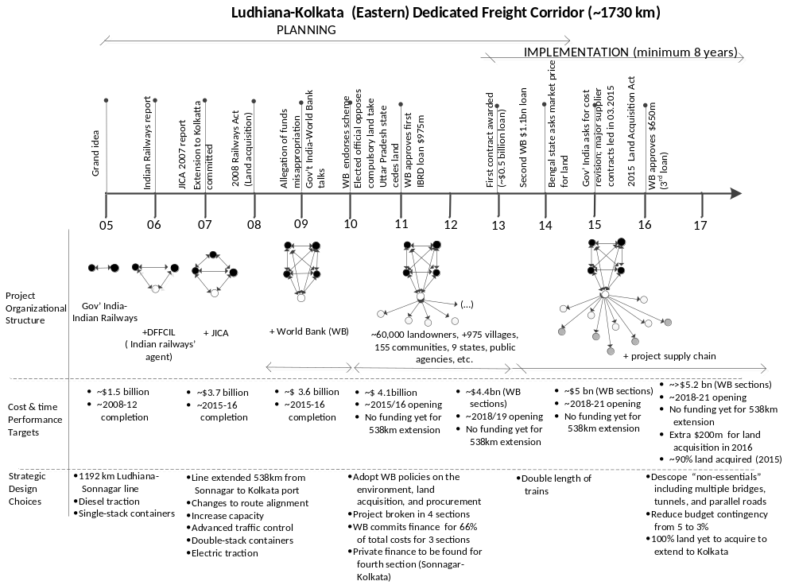
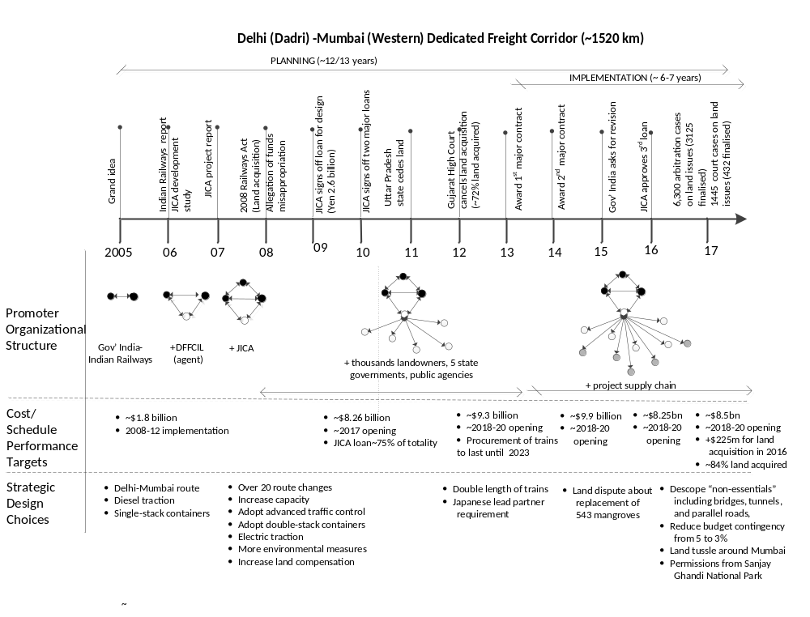
Figures 2a, b –Entebbe-Kampala Expressway and Kampala roads modernization (Uganda)
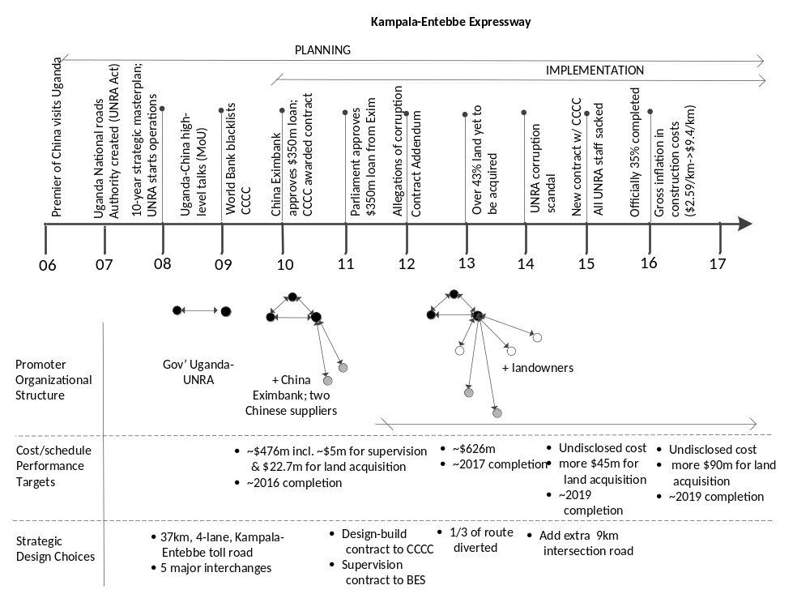

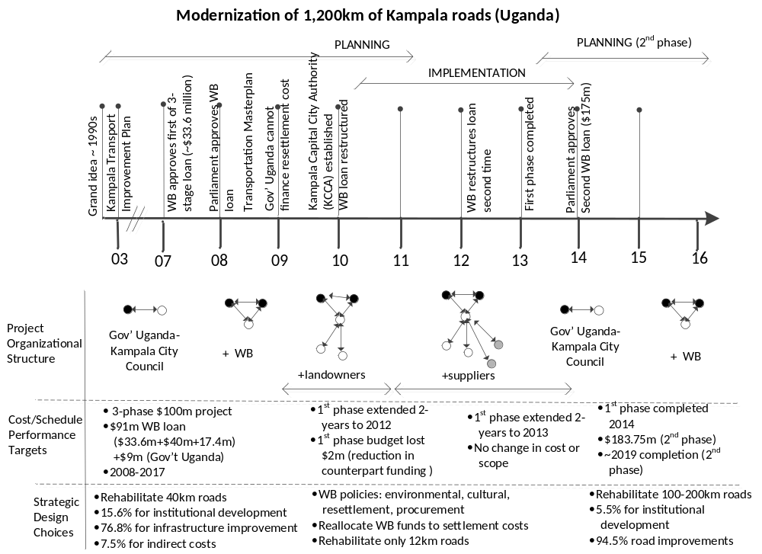
Figures 3a, b –Lagos Urban Metro Railway and Bus Rapid Transit Developments (Nigeria)

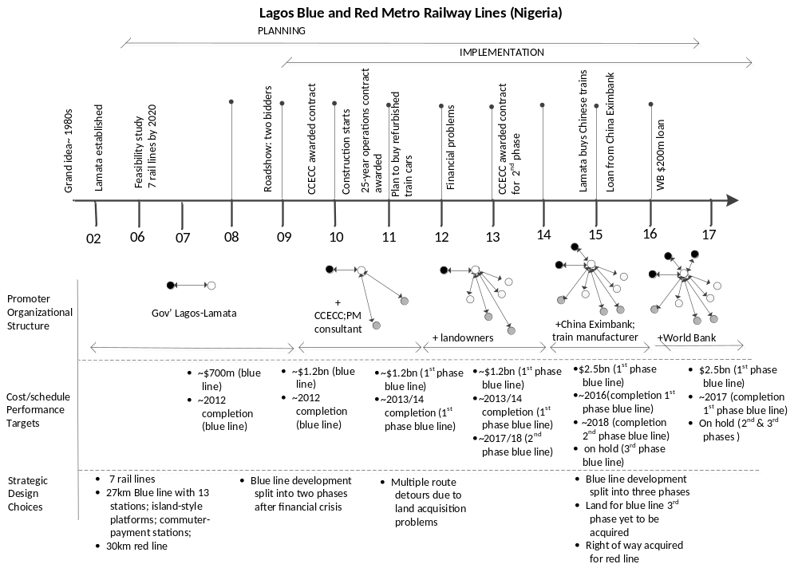
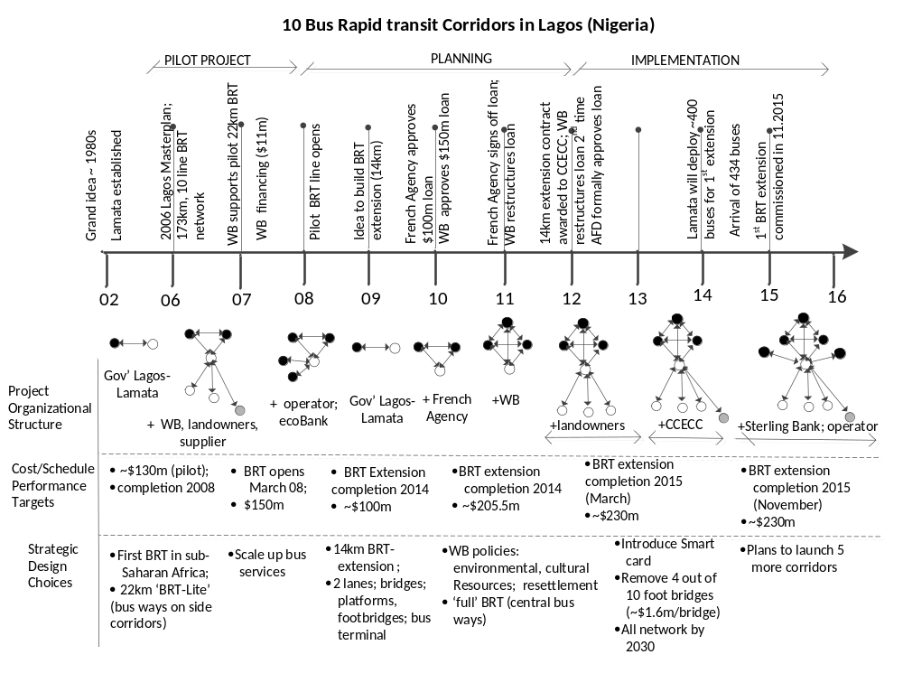
Figures 4a,b – Two models to structure a capital-intensive development process


